AFFORDABLE HOUSING
WAITING LIST
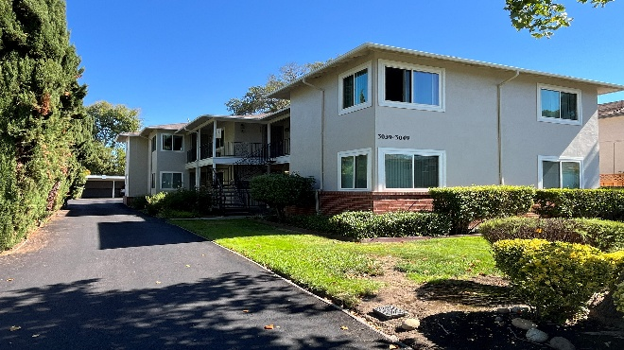
Waldo Apartments
3039-3049 Emerson Street
Palo Alto, CA 94306
1 Bedroom 1 Bath Available (531sf) Rent: $1,673 | Deposit: $1,673
Application Fee: $46.50 per adult household member
Administered under the Tax Credit Program

- Six One & Two Bedroom Apartments
- On-site parking and laundry room
- Conveniently located one block from El Camino Real
- Resident support services
- No pets
- No smoking in units
- Section 8 Certificates & Vouchers welcome
- Applications will be date & time stamped upon receipt of completed applications

Preference will be given to applicants who live and/or work in the City of Palo Alto
See Resident Selection Criteria for additional details.

Rental rates and unit sizes are assigned based on household size, income & availability
Rental Rates and Income Limits

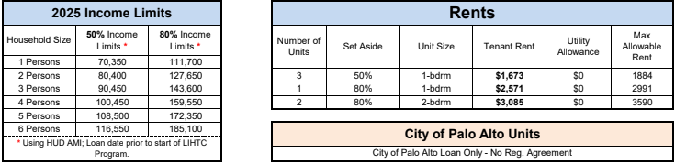

Note: Minimum Income Limits also apply.


Applications are available at:
Management Office, Oak Manor Townhouses & Scattered Sites,
630 Los Robles Ave., Palo Alto, CA 94306
Tel: (650) 858-2199 · Fax: (650) 858-8035 Equal Housing Opportunity

